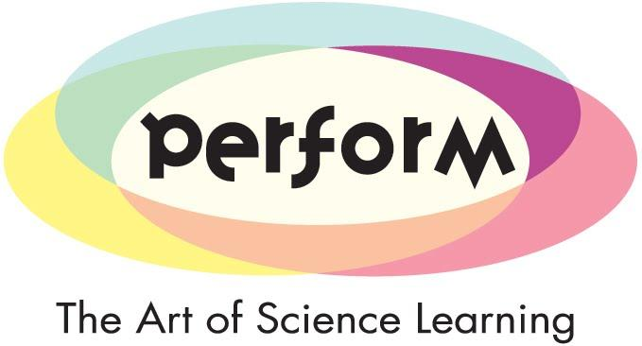

**PERFORM: Participatory Engagement with**

**Scientific and Technological Research through Performance**

**Information for participants**

*Science made simple* is working with researchers from the PERFORM consortium on a new research project designed to explore the effectiveness of using performing arts in science education to engage secondary school students in Science, Technology, Engineering and Maths subjects (STEM). To achieve this, we will conduct a participatory research process involving secondary school students, teachers and early career researchers in the development of science education projects using performing arts to explore relevant scientific topics at schools.

This research is funded by the European Commission through a grant to a consortium led by the *Universitat Oberta de Catalunya* –UOC, Spain. To conduct the research, this study will develop three case studies including a total of twelve secondary schools in France, Spain, and UK.

All of the procedures chosen for this study are widely used by social researchers and entail no risk to the participants. The Principal Investigator and other participants in the team have considerable experience with using these methods, having used them successfully in numerous social science research projects over the last 10 years. The PERFORM consortium will treat any personal information and data with the highest level of consideration, courtesy, privacy and ethical practice according to the corresponding national legal and ethical requirements.

The benefits of participating in the project include getting involved in a unique learning experience where students will have the opportunity to approach scientific issues with artists and researchers. Teachers and researchers will also receive training in science education and communication. Individuals will not be paid for participating in this study.

|  |
| --- |
| **If you are happy for your child to participate in this project, please complete the form overleaf with your child’s name, today’s date and your signature and return this paper to the school.** |

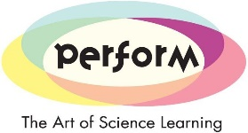

**Informed consent**

We are asking for your participation, because your daughter/son studies in one of the participating secondary schools and has been selected to take part in the PERFORM project. They will be asked to complete two surveys about their perception of science and scientific issues which affect society.

Participation in this study is strictly voluntary, and you are welcome to decline to proceed at any time. There are no penalties to people who decide not to participate, or who started to participate and later decided to withdraw.

Data from this project will only be available for the project’s key personnel. Data are completely confidential. All names will be replaced by coded numbers. Any publications, videos and reports to the funding agency will not identify participants by name. Data will not be used for any purpose other than scientific publications. Data will not be sold, given, or passed in any other way to third parties that might use it with any other purpose than research. Even in this case, we will ensure that third parties cannot identify the person who provided data.

Information will be used to inform academics and the general public about the effects of the use of innovative science education methods based on performing arts in fostering young peoples’ motivations and engagement with STEM.

Isabel Ruiz-Mallén is the responsible for the project, and you might ask her any questions about the project or the procedures. She will be visiting the schools at least once a year. You can also call her at 00 34 93 2535743 or send an e-mail to [iruiz_mallen@uoc.edu](mailto:iruiz_mallen@uoc.edu). If you have questions about your legal rights you may also contact her. To contact her, you can ask one of the project members at the school who will have complete instructions and will do it on your behalf at no cost for you.

By agreeing to participate and giving consent, you are not waiving any of your legal rights, claims, or remedies. You will keep the right to withdraw from the project at any moment, without explanations or further consequences. You may sign the form yourself or ask for someone else to sign on your behalf.

I have read (or someone has read to me) the information in this consent form. I have had an opportunity to ask questions and all my questions have been answered to my satisfaction. By signing this consent form, I willingly agree that my child participates in this study.

Name of participant (type or print):

Date

Signature of parent or guardian

I have explained the research to the participant and answered all of his/her questions. I believe that he/she understands the information described in this consent form and freely consents to participate.

Name of Investigator/research team member (type or print): **RACHEL MASON (science made simple)**

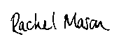

Signature of investigator/research team member Date **28 APRIL 2017**