**How to upload your deliverables**

1. Log in in the Participant Portal at:

<http://ec.europa.eu/research/participants/portal/desktop/en/home.html>

1. Click on “My Project(s)” in the section My Area:

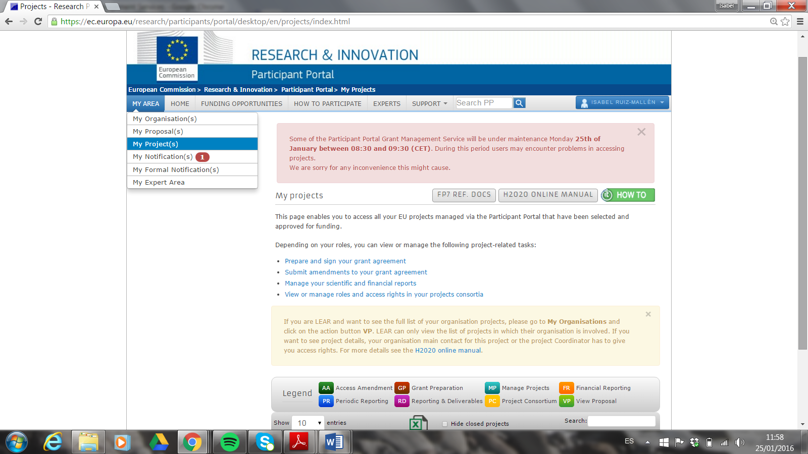

1. Click on the MP button on the right of project PERFORM:

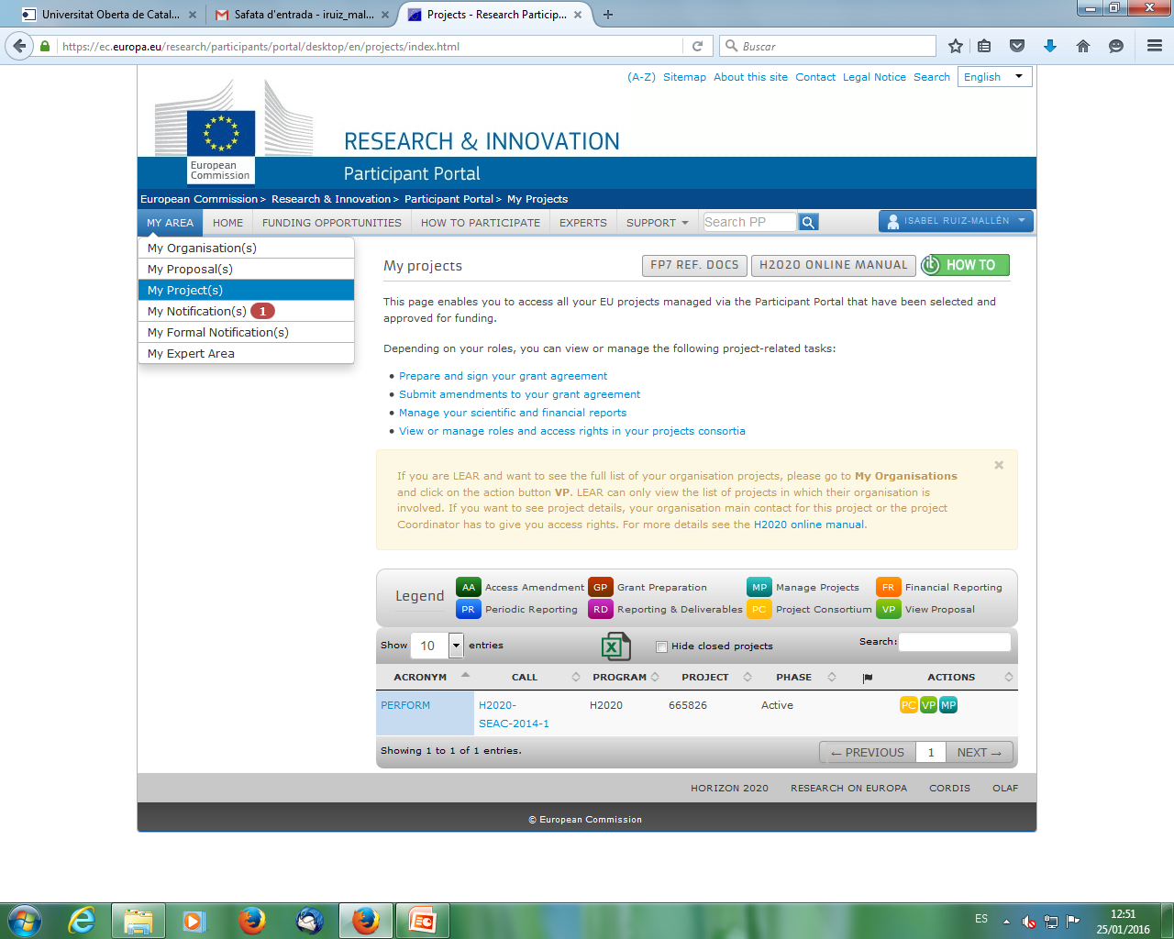

1. Click on “Continuous Reporting (data)”

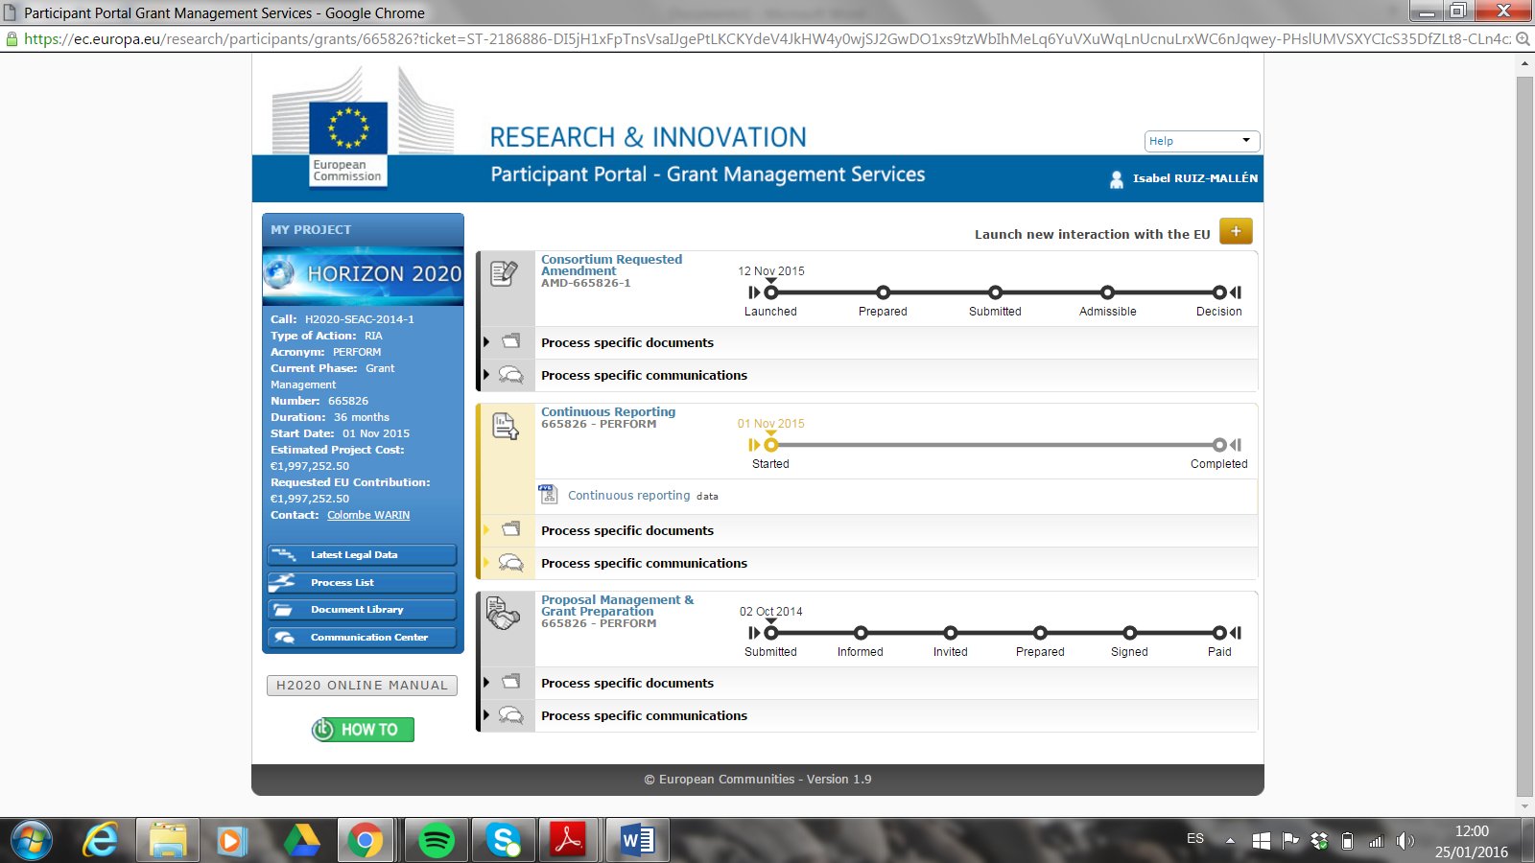

1. Push on the green button on the right to upload your deliverable:

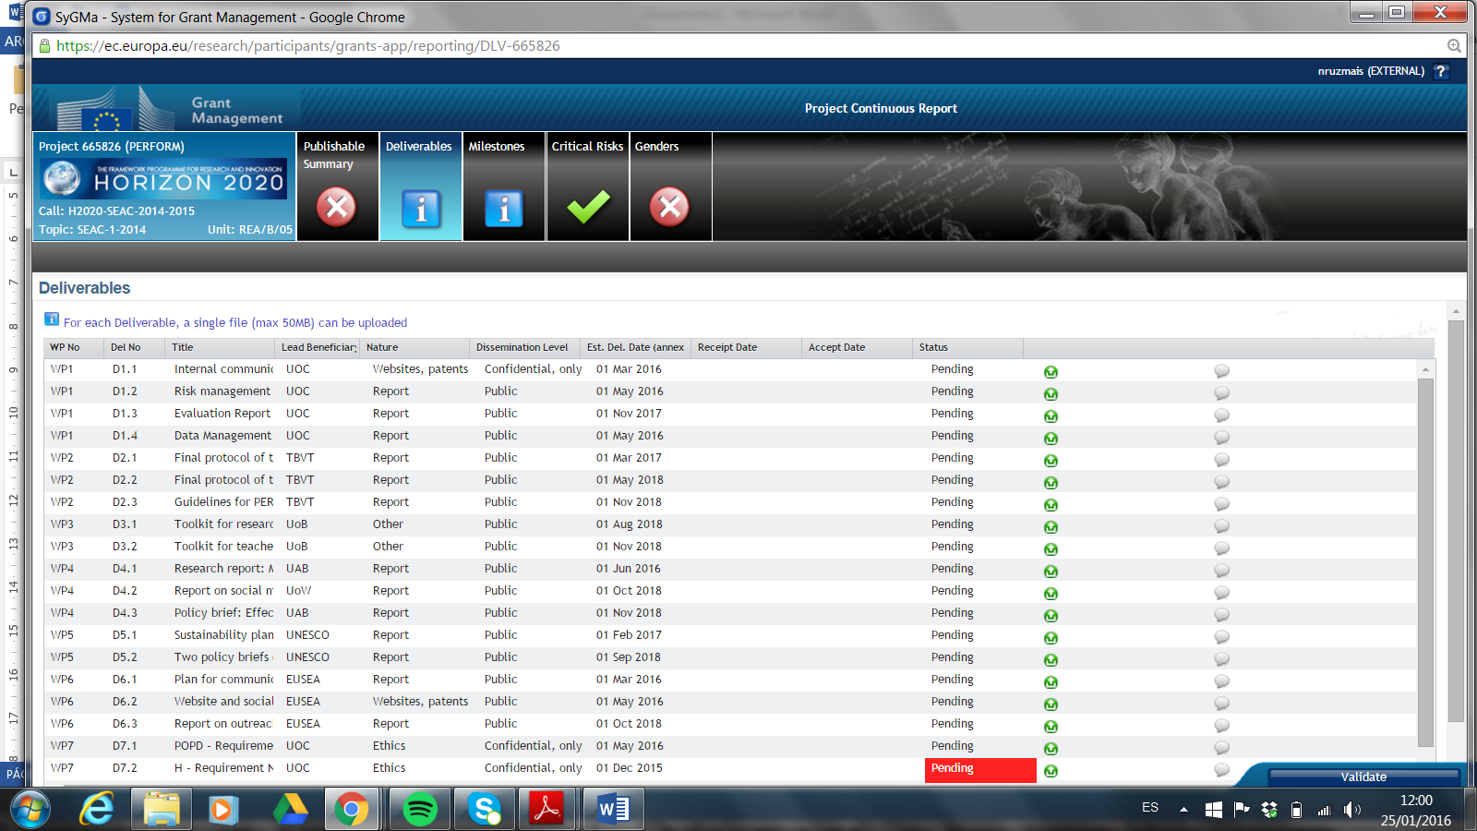

**How to upload your milestones**

