**Participatory Workshop 4: Arts & Scientific method**

**Goal**

To approach the scientific content and concepts previously addressed in the workshops through the lenses of stand-up comedy / science busking / clown.

**Specific Objectives:**

**1.** To identify connections between scientific research and artistic practice

**2.** To generate the script of the PERSEIA, where the scientific content is embedded in a story.

**PERSEIAs guidelines from T2.1 followed:**

EW5-Dialogue Science and Society

**Description of the Participatory Workshop:**

**Warming Activity (10’)**

Take into account in this section the loss of time due to the organization of the students into the room.

Deliver one or two warming exercises. These exercises should be “impro” games, in order to introduce the students to the generation of stories.

Mass participatory science warm up (8’)

putting a mobile phone into a balloon / sitting on a balloon as examples of how humour, smiling and volunteers are very good vehicles for relating inspirational science messages, that people will want to go home and try themselves. Time allowing at this point we would really emphasise the value of using volunteers in your busk and very quickly run through good practice in the use of volunteers.

Alternative option: The chairs (8’):

Each student takes a chair, put it somewhere in the room and sit on it. They cannot speak to each other. When the facilitator claps his hands, each one of the student has to exchange his or her seat with the further one very quickly. The first time, it is a mess. Then we make them think how to do it better, and make them start to think as a group.

At the beginning, when we say they have to exchange "quickly" they think it means they have to do it as fast as possible individually. Do not mix speed and haste.

Make eye contact with partners to be sure they are going to exchange with them.

Learn to compromise for the group: if the further seat is already promised to someone, try to find another one that is less far; the individual objective will not be perfect, but it is better for the group.

Brief introduction about the goal of the PW (2’).

**4.1- Catching-up with previous PW (10’)**

* Check if the students have the main structure of their pieces of PERSEIA:

Introduction: Presentation of the main scientific question

Core: the scientific content that they want to share in their piece of PERSEIA

Ending: Resolve the question posted in the introduction

Ask to the students if they did the homework. If yes, move to the next activity. If not, try to motivate them to do it with a brief talk about the importance of the structure to generate a good PERSEIA sketch.

* Ask to the students if they decided the role of each person of the SWG in their PERSEIA sketch.

**4.2-Participatory Activity: Arts & Scientific method activity (35’)**

The scientific method in arts and science (20’)

Divide students into two groups using any quick exercise.

Give an image to each group. Group A gets the image of an artistic work (e.g. a sculpture, an opera, etc) and group B the image of a scientific work (e.g a vaccine, a telescope, etc).

Explain that the image they have is the result of an artistic / scientific work and **ask them to perform 5 moments** **of the 5 steps** that the artists / scientists carried out to achieve that result (they should remain frozen, using their bodies as if they were photos). They have 10' to do so. The ECRs, SciCom and teachers join one of the two groups to answer questions and keep the conversation focused on the subject *(if possible, take a picture of each of the 5 “photographs” performed by each group)*

Group A performs its 5 moments. It is not necessary that all group members participate in the performance of the 5 moments. You can distribute the task and each image can be done by 2 or 3 students (or as many as are necessary).

Students in group B should interpret what they observe. Write down in the blackboard the main ideas that pop out in the discussion.

Do the same activity changing the role of each group: group B performs, group A guesses.

Open a discussion about the global processes and methods followed in both, arts and science, taking into account the concepts below:

*The scientific method outlines a basic plan for scientists to follow when answering a question: define the problem; form a hypothesis; experiment and make observations; analyse data and make conclusions; and publish, receive feedback, and revise as needed.[1]*

The artist hypothesizes through his or her initial creation, experimenting with the chosen medium and gathering research to enhance understanding of the problem or question. Once the artist has completed the initial creation, he or she will revise, rehearse, and make adjustments as necessary.

Discuss with the students that this methodology can solve problems and reach solutions in a reasoned and tested way:

*An individual does not have to be a scientist to use the scientific method. […]Individuals ask and answer questions, using the scientific method for common everyday problems.*

**4.3-Development of students PERSEIAs (Monologues, Impro, Science Busking):**

Once we have these first guidelines about the scientific method, we focus on how a monologue / Science Busking piece / Impro Clown Sketch is created.

Here, each SciCom. has to adapt the activities to their artistic discipline.

The use of Artistic Disciplines for Science Communication (50’)

Students have, from the previous PW, the main structure of their piece of PERSEIA. They have the introduction, the ending, and the scientific content that they want to explain in the core of their piece of PERSEIA.

During this activity, we will focus on developing the core of their PERSEIA sketch, writing their script.

(15’) Share with the students some important tips for the script development of a PERSEIA applying Artistic Disciplines:

* Structure your content in a logical way so your audience can follow it easily. Speak from the simplest to the most complex, think carefully how your ideas should be linked.

**Mystery busking exercise:**

Students (maybe in pairs) are given the chance to pick one item from a bag of random items (they cannot see inside the bag). Students have 8mins to design and practice a 2min presentation about the item they chose.

Students perform the busk at the front of the group.

Positive feedback taken from the group, as regards how the presentations with a strong story line made more sense and had more impact than presentations that had more of a list like structure.

Depending on the strengths of the group the sci com trainers have the option of emphasising the desirability of having some story element to the pupils presentations prior to the pupils formation of their mystery busks. Or after the delivery of the mystery busks, which can sometimes help the group to see a stronger contrast between lists and stories.

* Make your content relevant to your audience: as long as we will talk about a scientific content, it is especially relevant to think about how you will make the content relevant and important to your audience: Open the focus (start talking about more general things); relate to everyday life, emotions and interests of the audience.
* The use of humour: If humour is included (recommended but not compulsory): link distant ideas, create absurd or unexpected situations.

**Exercise: Make the ”ideas tree”**

Split the students in the SWG. Give to each student a big white sheet.

One student chooses a word related with STEM. Ex: Robot, and write it in the centre of the sheet.

The other students of the SWG write the first thing that comes to their mind when think on a robot. Ex: Terminator, artificial intelligence, drone…

Students let their sheet with their ideas and move to another table. They will find the sheet of another group and they will repeat the activity: they choose one word and they write the first thing that comes to their minds. Ex: If come from “Terminator”: film, Swarchenegger, humanity extermination…

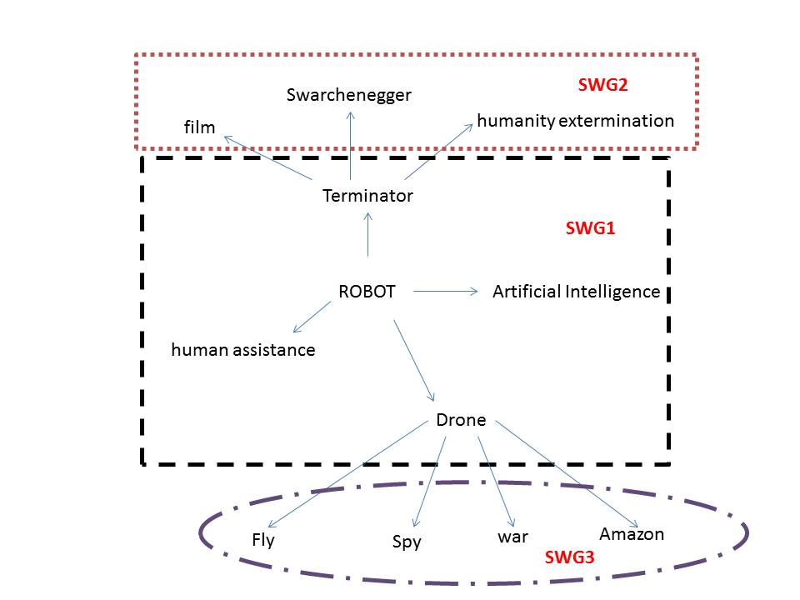

With this exercise you can create connexions between distant concepts, and it can help you to connect daily interests of your audience with your scientific content and to generate humour.

(35’) Split the students into the Specific Working Groups. Let them work on writing their PERSEIA sketch scripts following the guidelines designed by TBVT based on the “scientific method” and:

*Helpful feedback at this initial stage can be obtained by (1) identifying the key point of each para- graph/slide, (2) making sure that key point is expressed in the topic sentence or title of slide, (3) making sure relevant issues are within the body of paragraph or slide, and (4) assessing if key points are in the correct overall order[2]*

**4.4-Work proposal (10’):**

Students should continue with the script began in the PW4. They must finish writing the script of their PERSEIA sketch.

To do that, they can follow a methodology to analyse and improve their texts:

* Choose a part of your PERSEIA (a gag, a situation, the introduction…)
* Think about what are your expectations, what do you want to achieve with it. Write it down. Eg. Introduce the content, explain a scientific concept, raise curiosity in your audience, make them laugh…
* Test it! Read/delivery the text to your SWG peers, friends, family or classmates, ask them for feedback.
* Analyse their reactions and feedback (Did they understand your purpose? Did they want to know more about your content? Did they laugh?) and draw conclusions.
* Redesign your PERSEIA according to the conclusions reached.

SciCom will give to the students this methodology written in a paper and will share with them through the on-line platform.

Students share the script with ECR/SciComm/Teachers using the on-line platform from the school. If the school have not on-line platform, teachers can pick up homework and get them to SciCom, or they can generate a Blog.

ECR/SciComm/Teachers assist students in order to improve their scripts.

**RRI learning dimension topics faced:**

Social and civic competences: collective creation, cooperating within the group, negotiating content, discussing…

Inclusiveness of students: idem

Creative and critical thinking: identify relevant scientific content and critical questions, translate it into a stand-up monologue

1. Broaddus, A. (2013). The Scientific Method and the Creative Process. Berkeley Planning Journal, 26(1), 217–220. <http://doi.org/10.5811/westjem.2011.5.6700>
2. Parker, R. (2012). Skill Development in Graduate Education. Molecular Cell, 46(4), 377–381. <http://doi.org/10.1016/j.molcel.2012.05.003>