**Participatory Workshop 1: Selection of scientific topic**

**Goal**

Students understand the PERFORM project as a whole and they choose a scientific topic they want to talk, linking this issue with the European Union Societal Challenges (EU-SC).

**Specific Objectives**

1.- To assist students to understand the overall project, the importance of generating a PERSEIA and the steps to be followed: Explanation of how PWs will be implemented, indicating that group work will be done during the workshops and that students will do homework outside school hours. Explain to students that they will receive online assistance from the ECR and SciCom and onsite assistance from their teachers to do the homework associated with generating their PERSEIA.

2.- Explain to students the relationship between Art and Science: A brief reflection on the usefulness of the transmission of scientific content through the performing arts. Introduce the artistic discipline that each CSC will use.

3.- Make students aware of the relationship between different scientific areas, the EU-SC and STEM-Jobs, giving to them tools to choose the scientific content of their PERSEIA sketch.

4.- Establishment of SWGs and PERSEIAs’ topic selection.

**PERSEIAs guidelines from T2.1 followed:**

EW1-STEM JOBS

EW4-EU Societal Challenges

General Recommendations: Use of Social Networks / Make PERSEIA interactive

**Description of the PW:**

**Introduction to the PERFORM project actors (5´)**

SciCom introduce themselves briefly.

ECRs introduce themselves briefly.

Move to next section.

**Warming Activity (10’)**

Take into account in this section the loss of time due to the organization of the students into the room.

Write your name warm up (3’):

Pupils ECR’s teachers and trainers, stand in a circle and write their full name in the air with their right index finger, then left index finger, then right big toe, then left big toe and then with their bottom.

Stage me (3’):

All students are placed in a circle, facing outward. The SciCom says a profession or feeling and everyone turns quickly and stays frozen in a posture that dramatizes what was said. Examples: laboratory mice, monologuist, DNA, laugh, geology…

**WP4 Assessment activity (10’):**

Pre-survey

**Participatory Activity: Introduction to PERFORM project**

1.1-General explanation of PERFORM project: PWs + Homework + OI **(20’)**

* Guide students to understand the objectives of the PERFORM project. Show students the final result of the project: the PERSEIA. SciCom guide a discussion with the students where the project structure is built, using blackboard and chalk.

SciCom writes "PERSIA" on the blackboard. SciCom makes a brief description of the concept (see figure 1) *(10’)*.

* Brief reflection about the usefulness of the transmission of scientific content through the performing arts *(2 a 3’)*.
* Each CSC should define the best way to explain their artistic discipline in approximately seven or eight minutes.

SciCom writes “HOW TO CREATE A PERSEIA?” on the blackboard. Students are asked how they would do it. Keep on the left side of the board an area to write the main ideas that students propose *(3’)*.

SciCom structure the ideas that students have proposed in three main sections writing on the right side of the board: "CONTENT", "CLARYTY" and "CHARISMA" *(1’)*.

SciCom ask students what key elements must be taken into account in each of the main sections. The ideas of students are writing on the left side. SciCom structures each of the main sections in the six PWs. For each PW should explain their goal and objectives (10’).

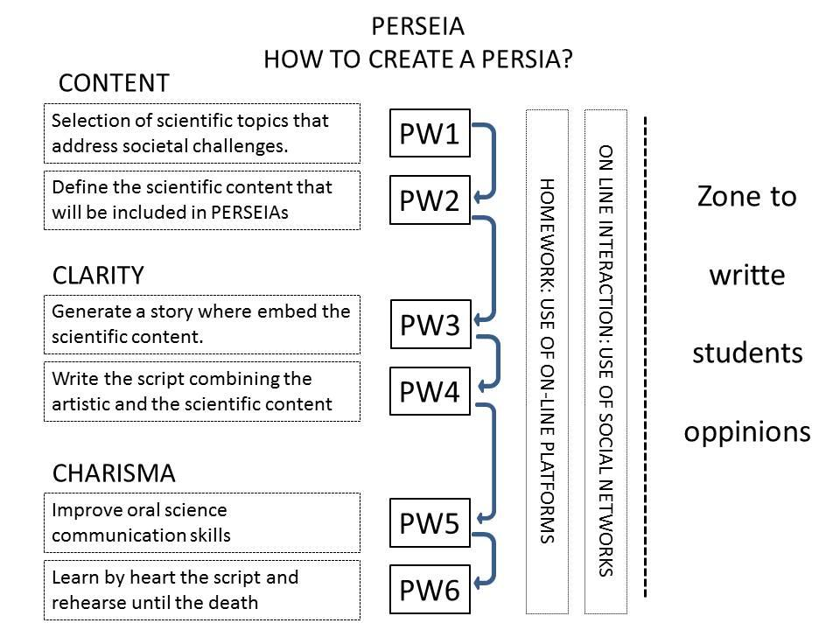

**Figura 1:** Bloackboard scheme to drive the activity

SciCom structures each of the main sections in the six PWs. For each PW should explain its goal and objectives (10’).

SciCom explain to students that between each PW they will have small tasks (homework) to generate its PERSEIA sketch. Students will be assisted to do their homework by ECRs and SciCom through Social Networks.

It links directly to the next activity.

1.2-Show scientific issues related to the EU-Societal Challenges **(50’)**

MATERIAL: *Detailed information at the end of the document.*

* Three types of MAGIC cards will be generated, with a picture and a short description:
* PROJECT cards with the eight EU-SC and with specific projects associated to each EU-SC
* SCIENTIST card: photo of the scientist and brief description of their capabilities. Example: Photo; Scientist with a micropipette. Description; person able to understand how genes work and modify the genome of cells and/or animals.
* PLACE card: photo of a workspace with brief description of what is done there. Example: Photo; molecular biology laboratory. Description; Laboratory where are made experiments to modify genes and to study the effects of drugs in cells and/or animals...

DESCRIPTION OF THE ACTIVITY

Split students in the SWG. It will be the first time that students are splitted in the SWG. And they are going to maintain these SWGs during all the process. Take the time to do these groups.

The SciCom explains the game, showing students all the elements (EU-SC cards, Magic cards and Reference cards).

Each SWG chooses a card with an EU-SC. The "Magic" cards are placed in a table in the center of the room, into two groups, group "Cards of Place" and group "Scientists Cards". Each SWG is referring to the different cards, looking for the most suitable to address its EU-SC.

The ECRs and teachers have the “Reference cards” that the students can consult to help them to understand and adress the scientific challenge proposed.

ECR and the teacher will help students to understand the concepts and explaining and solving the doubts that arise. The SciCom will keep students focused on the activity and be responsible for maintaining order, preventing too much noise or out-of-control situatons.

Finally, the students will explain to the whole group their ideas to address EU-SC using the Cards. The role of the ECRs will be complementing the explanation of the students saying if the explanation is scientifically possible or not.

**1.3-Development of Students PERSEIA (15’)**

Split students into SWG

Each SWG chooses a scientific topic to talk about in their PERSEIA sketch.

*They should answer the “learning chart” provided by WP4.*

The teacher, the ECR and SciCom will interact with the SWG analyzing the students' reasons for the choice of the scientific topic. Facilitators should help students to choose a suitable subject to create the PERSEIA: “because the topic motivate all of the students, because they already know about it or they want to know more about it, etc”

**1.4-Work proposal & Description of the online activity (10’)**

Remind students that a virtual space in the school Moodle has been created, where they can upload the homework.

Each SWG must choose the scientific subject to talk about in their "piece of PERSEIA” and send a brief description for choosing that topic, answering a few brief questions (designed by TBVT). They should upload the text to Moodle.

**RRI learning dimension topics faced:**

Basic cognitive aspects of the scientific topic

Attitudes and perceptions of science

Inclusiveness of students

¿Engagement (cognitive and emotional)?

**Students’ transversal competences worked:**

Sense of initiative: To choose a scientific topic for converting it into a monologue.

*Social and civic competences:* Students collectively choose a topic through group discussion.

Learning to learn: To generate a telematics space for interaction with ECR/SciComm. Students interrogate themselves about what they know about a given scientific topic and what motivates them to learn more; students pose (research?) questions about the topic.