**KNOWLEDGE SHARING WORKSHOP SUMMARY**

**Intro**

The PERFORM Knowledge Sharing Workshop took place at St Werburgh’s Community Centre, in Bristol, from the 4th to the 8th of April 2016.

The main idea of the workshop was to provide a space for the different partners to be able to share their respective skills and in this way to improve the quality of the different activities that will be developed within the project such as the PERSEIAS and the trainings.

The different aspects/topics to tackle in the workshop were identified by asking the different partners about the needs they felt they had and the skills they felt they and others could contribute. After a survey sent to all the partners the topics identified were: participation, reflexivity, responsible research and innovation.

We also wanted to have the different voices of the groups involved in the project, so we had a session around the focus groups that had already happened to get the voice of the students and we also had a session with early career researchers to gather their opinions about the project and their potential involvement.

We have a voice missing at the moment, which is the one of the teachers, so we are organising separate meetings to discuss their views and needs around the project.

During the workshop some issues that needed tackling arose, so, on Thursday, part of the reflexivity training had to be cancelled to work in groups around some coordination issues for the different work packages.

Finally, on the Friday afternoon some time was left for the performers to get the opportunity to work together.

Because of the idea of applying reflexivity to ourselves as participants in the project and to the management of the project that was mentioned in the kick off meeting, we decided to hold the meeting in a community centre rather than in a more “official” venue, to reduce the costs of hiring the space and also to contribute to local economy.

**Participation workshop/discussion**

The aim of this session, led by Kat Wall from UoB was to share views and experiences from different partners and to get some ideas from external projects. We invited Shani Ali from Room 13 Hareclive (http://www.room13hareclive.org.uk/) and Rachel Clarke from Knowle West Media Centre (<http://kwmc.org.uk/>) to present some of the work they’ve done with young people and participation.

After some presentations of case studies on young people participation we had a discussion about potential challenges of participation and how to solve those.

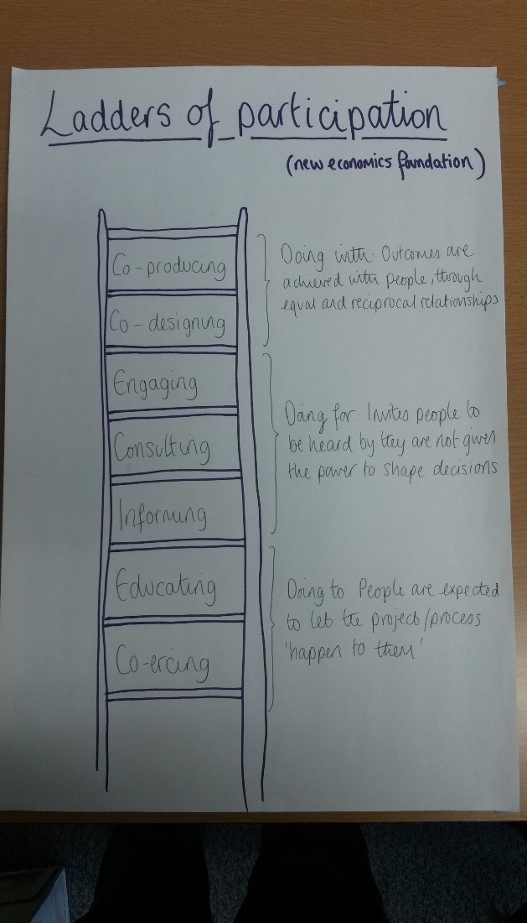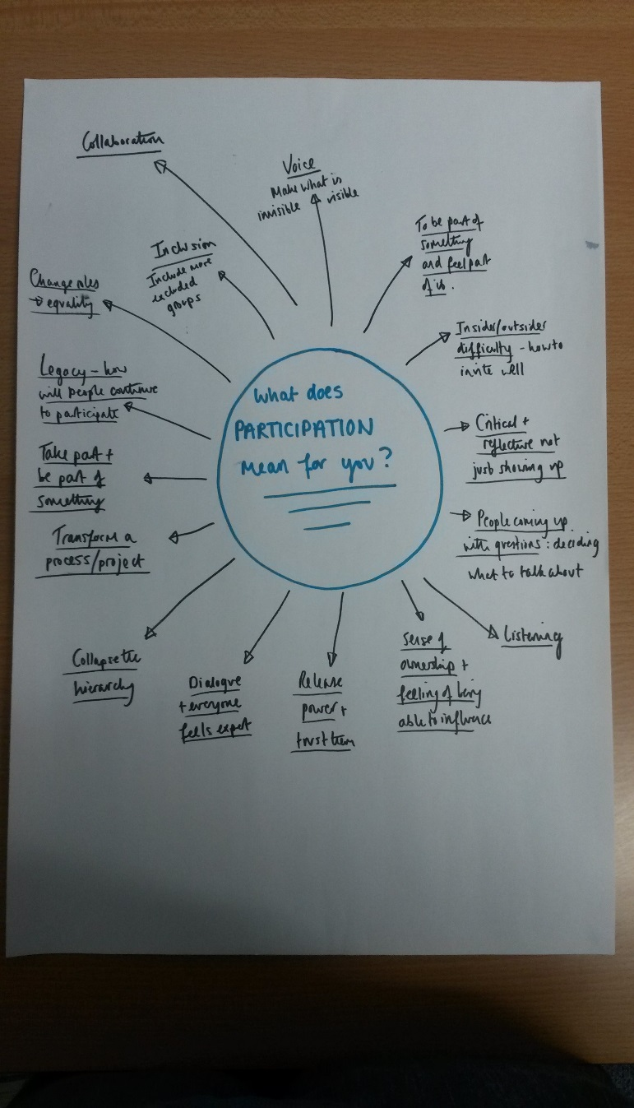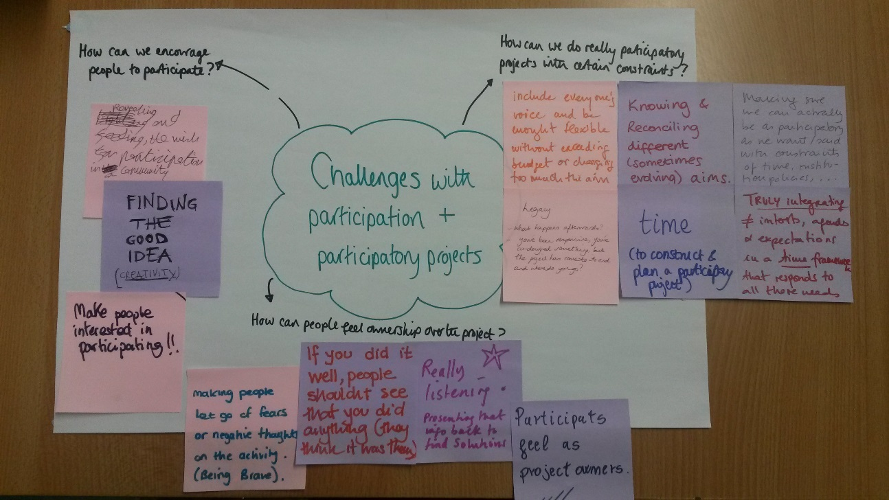

**Group agreement**

In order to create a space of sharing where everyone felt comfortable we jointly created a group agreement of what we wanted and didn’t want in terms of context and interactions for the Knowledge Sharing Workshop week.

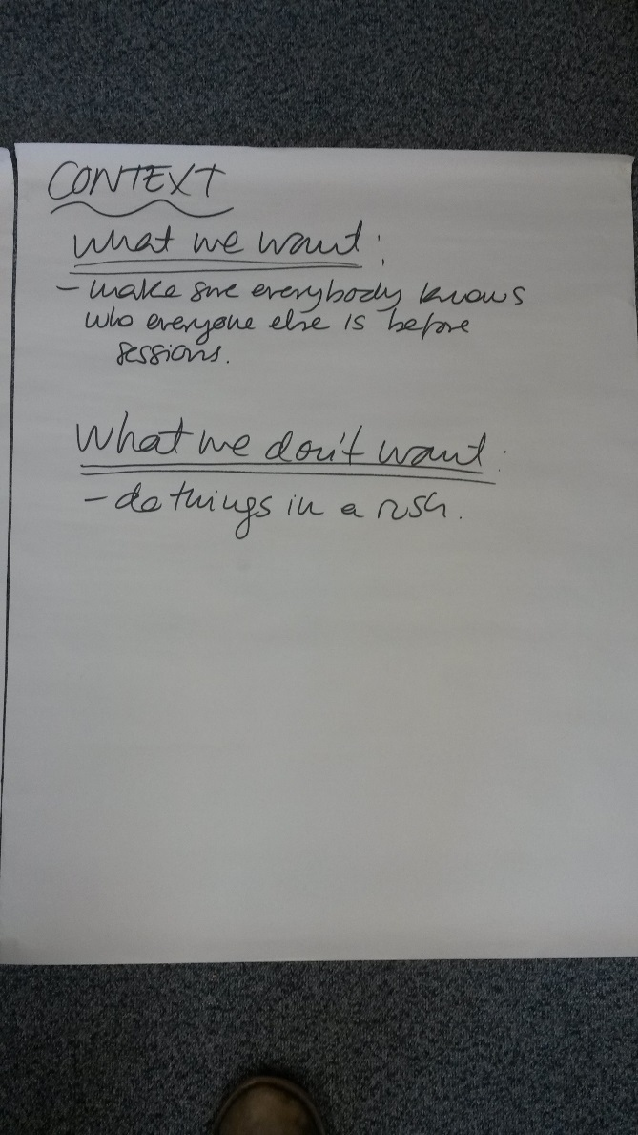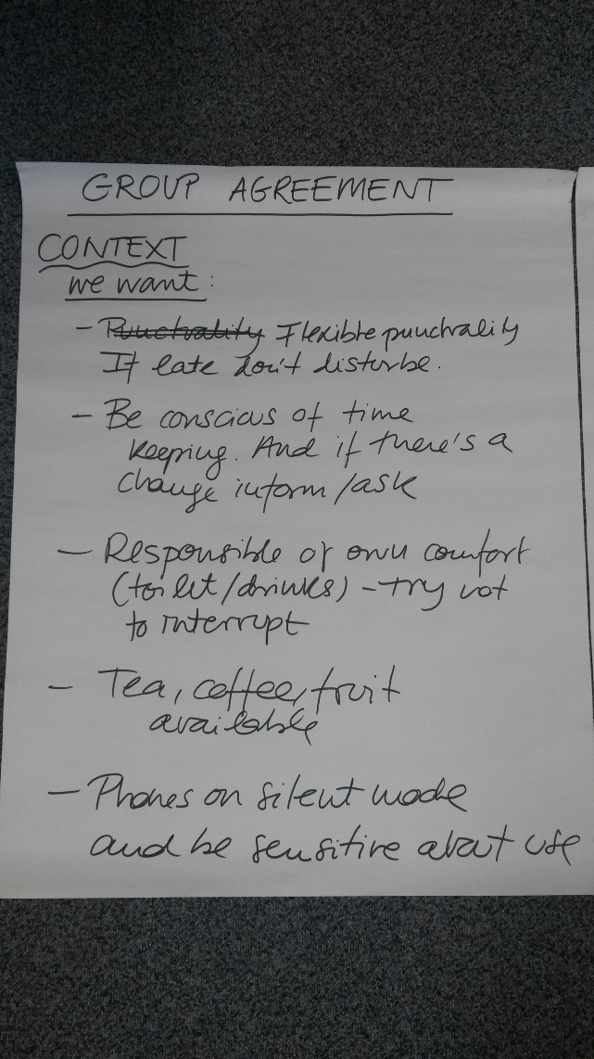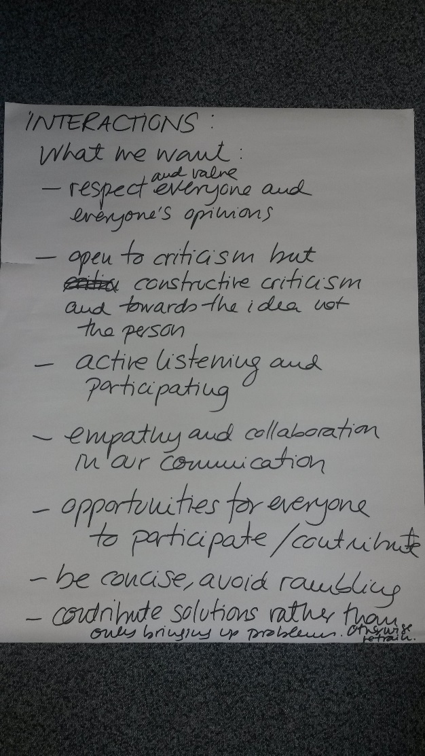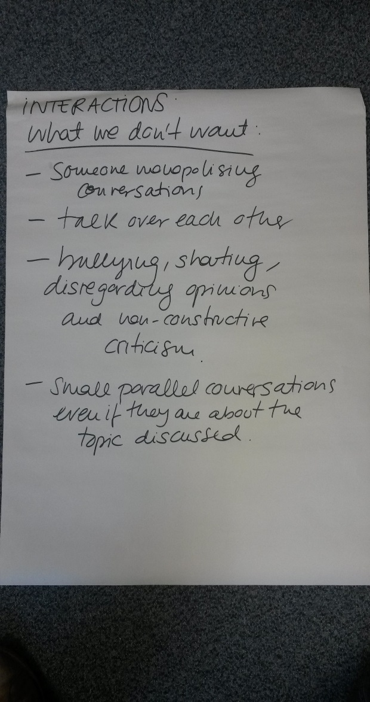

**Discussion of the results from the focus groups**

This session led by work package leaders Oriol Marimon and Helena Gonzalez from The Big Van Theory was an opportunity for all the partners to get an update on the work done by WP2 around the focus groups in schools.

Oriol and Helena gave an overview of the different focus groups that have been created around the topics of: STEM careers in labour markets, science related stereotypes, ethics in scientific research, EU societal challenges, dialogue between scientists and society, gender inequality and girls barriers in STEM.

Results from the focus groups that have already happened in Spain were presented and discussed and recommendations and improvements were made for the focus groups that still need to happen in France and the UK.

**Reflexivity on Science Communication**

The sessions on Reflexivity on Science Communication were designed and delivered by Claire Ribrault and Livio Riboli-Sasco, from Atelier des Jours a Venir. The programme was designed to take place over three days, but because of some project discussion needs between the coordination of different work packages the reflexivity sessions had to be reduced to two days and a half.

During the training we looked at how to apply reflexivity to the project, from the communications we issue and if we are really communicating our messages properly, to the values of our different insittutions and how those fit with the project and with our reflexivity approach. We also did some exercicies on how to include some of the reflexivity concepts into performance, which proved a really useful exercice in terms of the future development of PERSEIAS.

We also explored our perceptions of science, looked at its values, reflected on its neutrality, and on its practice inside different institutions and when having to deal with different pressures to produce results as well as looking at some reactions from different groups or researchers to those current pressures.

As next steps after the reflexivity workshop as a consortium we agreed to finish up a new version of the press release that we feel reflects us better, finish the manifestos for the kind of researchers and research practice we want to involve in the project, and compromised on collecting real science stories that could be used with students to reflect on science practice.

**Work Packages working together**

Thursday morning the reflexivity session was cancelled so that the different partners involved in the different work packages had the chance to discuss progress, challenges and next steps. A summay of the commitments made by each work package is on annex 3.

**Responsible Research and Innovation session**

During this session led by Isabel Ruiz from UOC and Maria Heras from UAB, an introduction to RRI and the rational behind it was presented. We then discussed RRI in the context of RRI and which issues around diversity and inclusion, anticipation and reflection, openness and transparency and responsiveness and adaptative change we felt needed tackling from the perspective of the work of the different work packages and institutions. Based on this discussion, in the months to come, Isabel and Maria will suggest to the consortium a set of RRI process requirements to be followed, together with a set of questions to effectively monitor the inclusion of RRI in the different stages of the project.

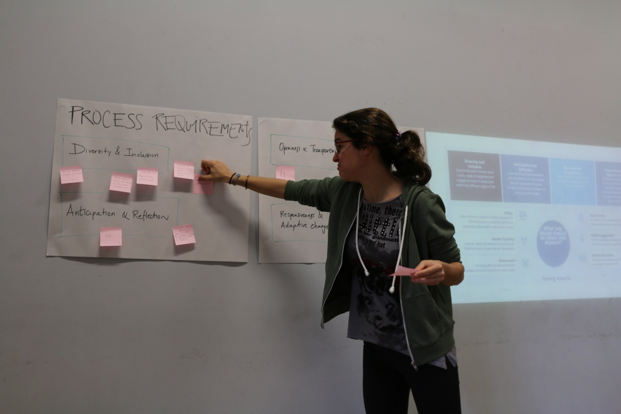

**Early Career Researchers discussion**

Several PhD students from UoB were invited to join us for a session to explore researchers involvement in the PERSEIAS and the training they would need for that.

Researchers were split in several groups with different consortium members and the following issues were tackled in groups: involvement of researchers in PERSEIAS, benefits in getting involved in PERFORM, challenges/barriers to getting involved and potential solutions and tranning needs and the best formats.

The group discussions were very productive and provided some new ideas and insights that we will follow up from WP3.

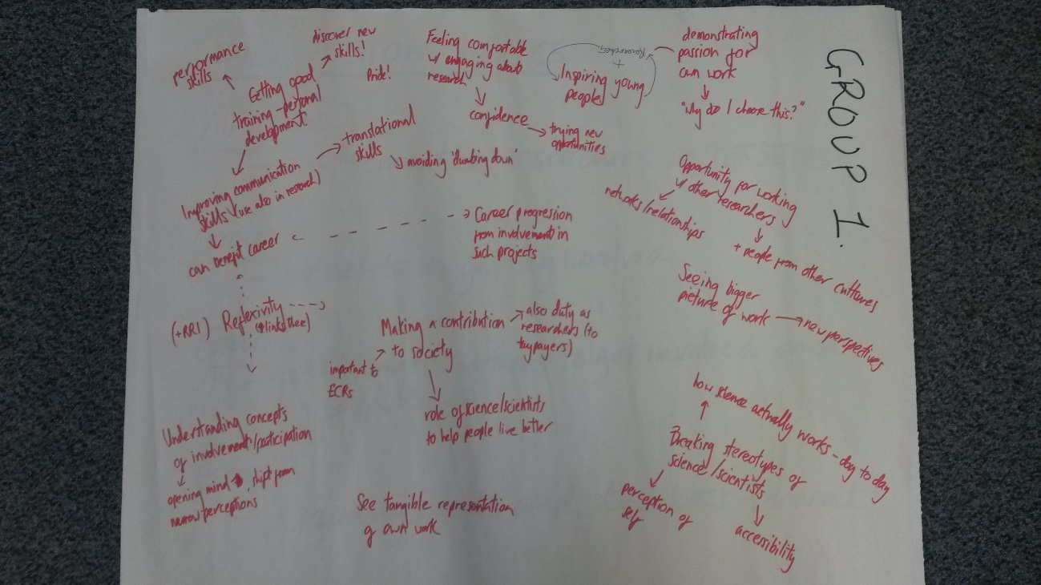

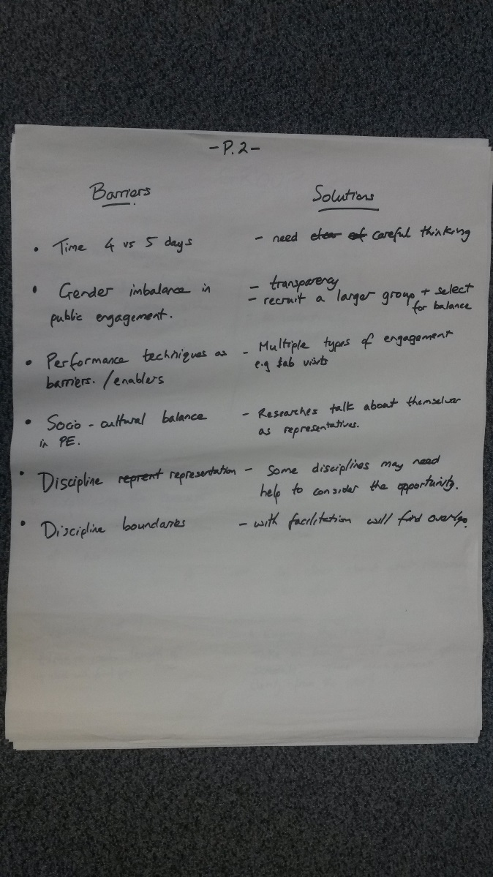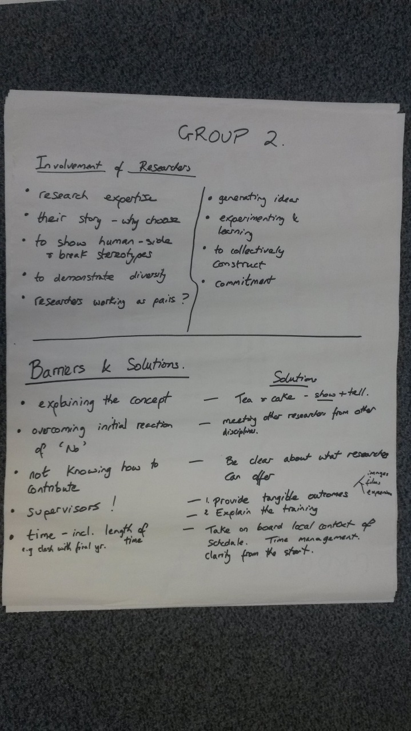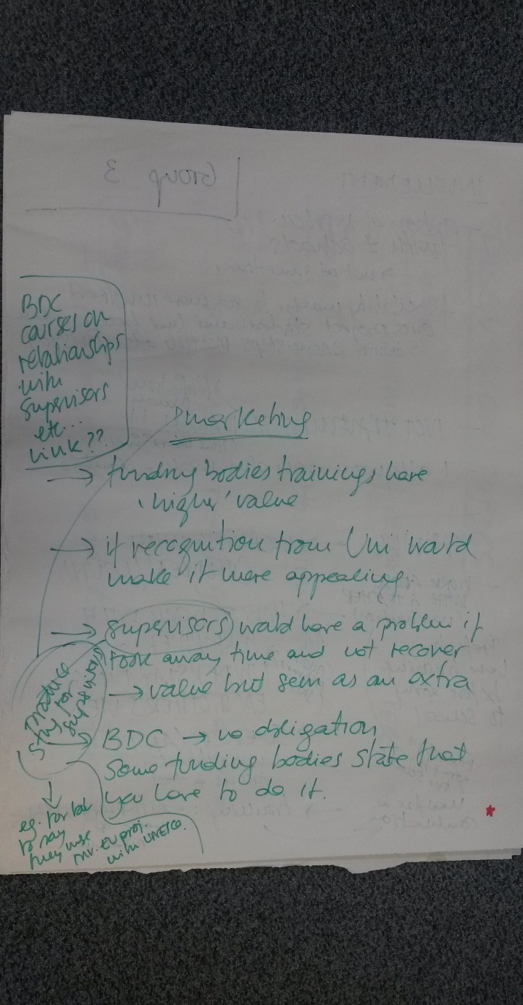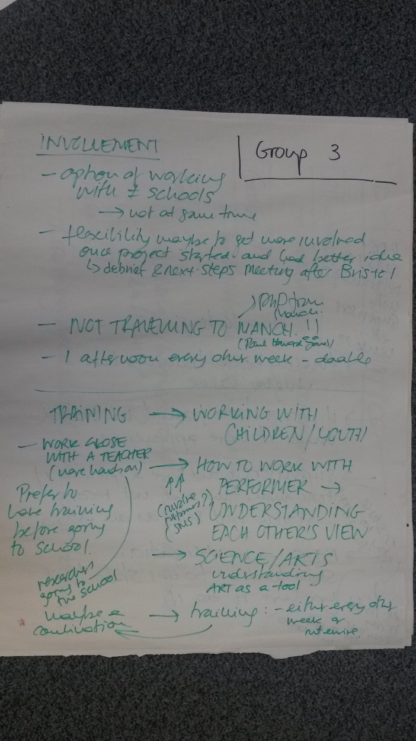

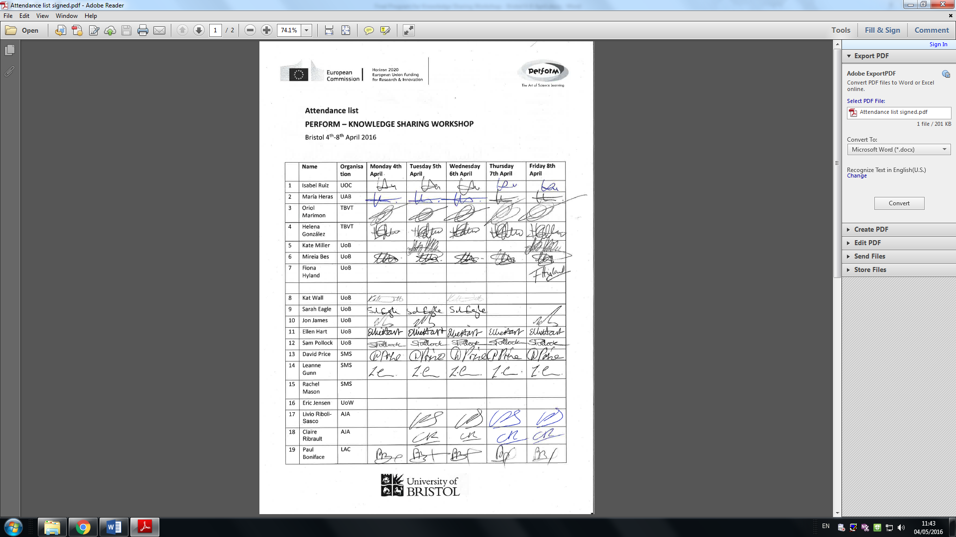**ANNEX 1 – ATTENDANCE LIST**

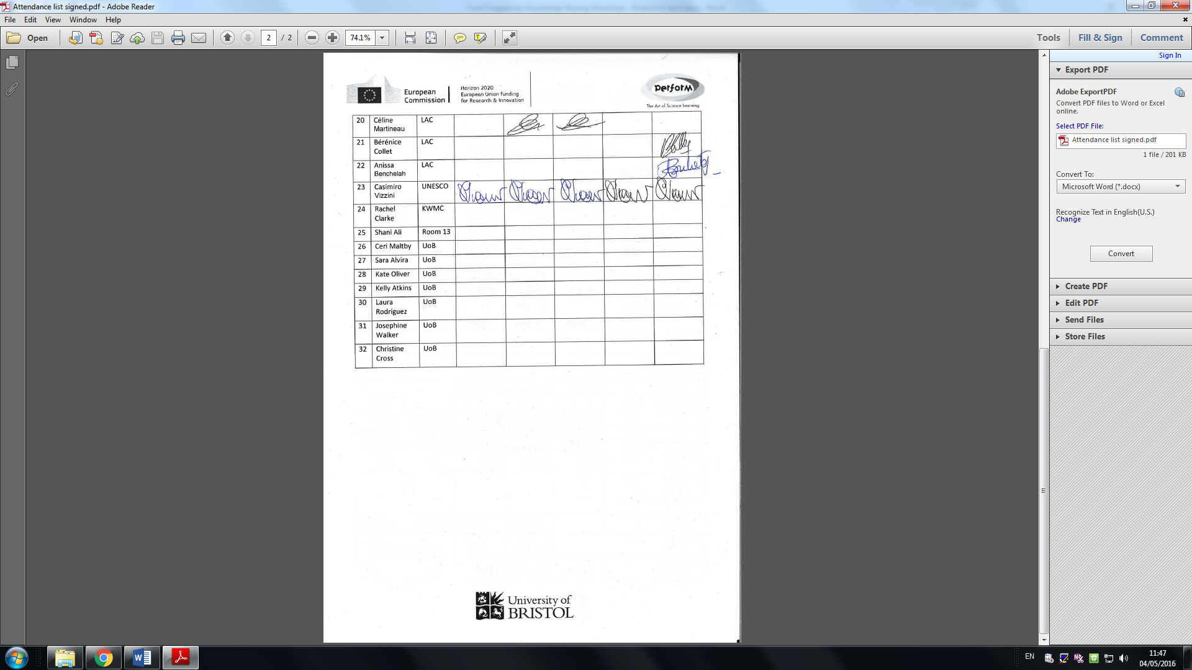

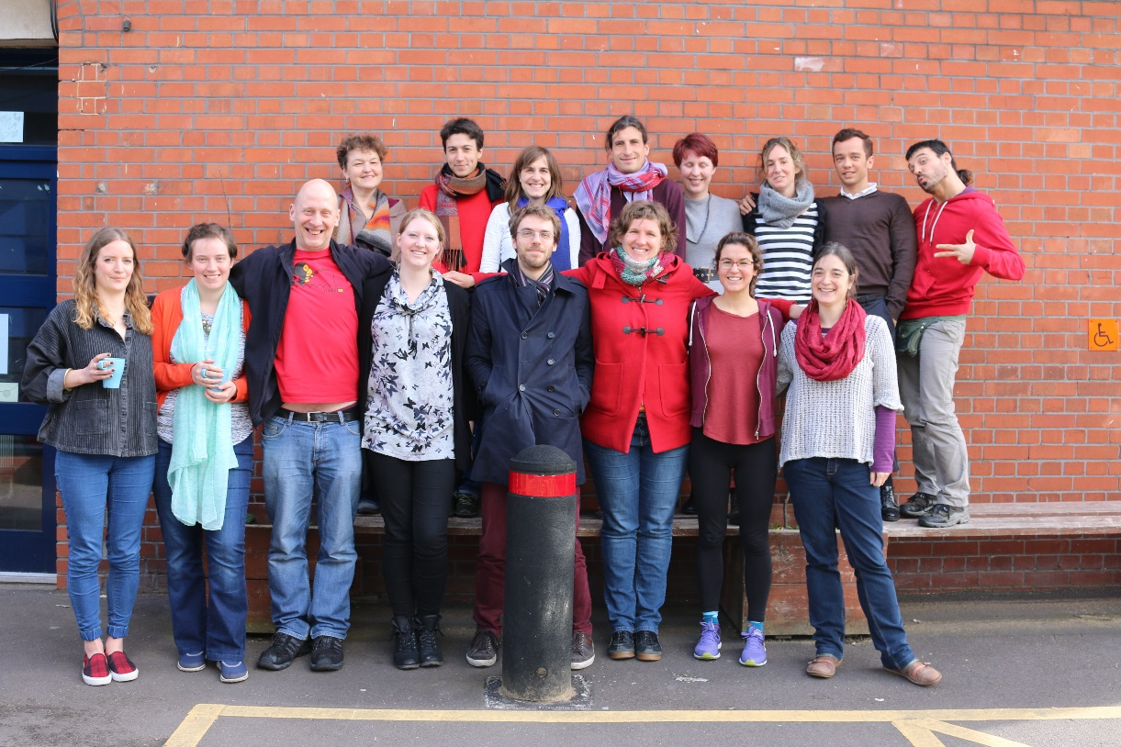

**ANNEX 2 – KNOWLEDGE SHARING WORKSHOP PROGRAM**

**PERFORM – KNOWLEDGE SHARING WORKSHOP**

Bristol, 4th-8th April 2016

**PROGRAM**

**Monday 4th April**

|  |  |  |
| --- | --- | --- |
| Time | Activity | Responsibility |
| 9:00 – 10:30 | Steering committee meeting (WP leaders) | Isabel Ruiz (UOC) |
| 10:30 – 11:00 | Break |  |
| 11:00 – 13.00 | Participation Workshop / Discussion   * Pecha Kucha presentations of different case studies (Room13 - Shani Ali, Teenage Walks - Rachel Clarke and Citizen Science by Atelier - Isabel Ruiz) * Definitions of and challenges with participation * Action planning/problem solving challenges with participation | Kat Wall (UoB) |
| 13.00 – 14.00 | Lunch |  |
| 14.00 – 14.45 | Group agreement for the week | Mireia Bes (UoB), Isabel Ruiz (UOC). |
| 14.55 – 15.00 | Break |  |
| 15.00 – 18.00 | Discussion of the results from the focus groups   * Explanation of the Focus Groups * Improvements that could be applied in the Focus Groups implementation * Converting Focus Groups in activities to talk about RRI with young people * Revision of the results from Spain | Helena González and Oriol Marimon (TBVT) |
|  |  |  |
| 20.00 | Dinner at the Riverstation Restaurant -- The Grove, Bristol BS1 4RB |  |

**Tuesday 5th April**

|  |  |  |
| --- | --- | --- |
| Time | Activity | Responsibility |
| 9:00 – 13.00 | Reflexivity on Science Communication Day 1 – Critical analysis of the different motivations to communicate about science. What are the political dimensions of science communication?  • What do we know about youth interest in science, scientific careers?  • What is meant by "knowledge society"  • Who is doing/promoting science communication?  • Values and science | Livio Riboli-Sasco and Claire Ribrault (AJA) |
| 13.00 – 14.00 | Lunch |  |
| 14.00 – 18.00 | Continuation of the reflexivity workshop | Livio Riboli-Sasco and Claire Ribrault (AJA) |

**Wednesday 6th April**

|  |  |  |
| --- | --- | --- |
| Time | Activity | Responsibility |
| 9:00 – 13.00 | Reflexivity on Science Communication Day 2 – What does it mean to be transparent about science?  • Distinguish Science / Research / Academia  • Introduction to feminist epistemologies : standpoint theory, situated knowledges  • A diversity of research practices : dominant modes vs resistant practices  • Analysis of different examples of participatory approaches of science | Livio Riboli-Sasco and Claire Ribrault (AJA) |
| 13.00 – 14.00 | Lunch |  |
| 14.00 – 18.00 | Continuation of the reflexivity workshop | Livio Riboli-Sasco and Claire Ribrault (AJA) |
|  |  |  |
| 19.00 | Dinner at Benjamin Perry Boat House (Phoenix Wharf, Lower Guinea Street, Bristol BS1 6TJ) and performance workshop by Science Made Simple and The Big Van Theory |  |

*we need to get out of the room by 18.15 as there’s something else afterwards

**Thursday 7th April**

|  |  |  |
| --- | --- | --- |
| Time | Activity | Responsibility |
| 9:00 – 13.00 | Reflexivity on Science Communication Day 3 – What is (are) our position(s), in PERFORM, as science communicators?  • Within PERFORM, what are our positions with respect to science and scientific research? What are the implications for the project?  • Combining art & science: Why? How? Analyse different examples.  • How to build a transparent discourse, and stimulate critical thinking? How to situate / contextualize scientific knowledge? | Livio Riboli-Sasco and Claire Ribrault (AJA) |
| 13.00 – 14.00 | Lunch |  |
| 14.00 – 18.00 | Continuation of the reflexivity workshop | Livio Riboli-Sasco and Claire Ribrault (AJA) |

*we need to get out of the room at 18.00 as there is a lesson afterwards

**Friday 8th April**

|  |  |  |
| --- | --- | --- |
| Time | Activity | Responsibility |
| 9:00 – 11:00 | Responsible Research and Innovation session:   * What is your understanding of RRI? * How would you include RRI in PERSEIAs? | Isabel Ruiz (UOC) and Maria Heras (UAB) |
| 11:00 – 11.15 | Break |  |
| 11:15 – 13.00 | Discussions with early career researchers | Mireia Bes, Kate Miller, Fiona Hyland, Kat Wall (UoB) |
| 13.00 – 14.00 | Lunch |  |
| 14.00 – 18.00 | WP2 working group | Helena González and Oriol Marimon (TBVT) |
| 14.00 – 16.00 | Atelier – Centre for Philosophy of Science | Livio, Claire, Ellie, Sam |
| 16.00 – 17.00 | UOC / UAB – Cabot Institute | Isa, Maria, Hayley |

**ANNEX 3 – COMMITMENTS FROM THE WP WORKING SESSIONS**

**Commitments resulting from the KSW in Bristol**

**Commitments related to WP2:**

* **Revision of FG and FG-Results from Spain**:

1. FG improvement suggestions have been applied to FGs. See Reformulated-FG.
2. FG sessions have to be recorded
3. FG have to be renamed to Participatory Workshops
4. Diversity group from “Consell de Cent” have to be tacked out from analysis.
5. Reanalyse subcategories in FG1
6. Analyse Low/Medium independently
7. Analyse Spain/France/UK independently
8. Include students opinions that allows us to extract conclusions

* **Organitzation of Task 2.2 PERSEIA**: Participatory workshops of Task 2.2 will be implemented following next scheme:

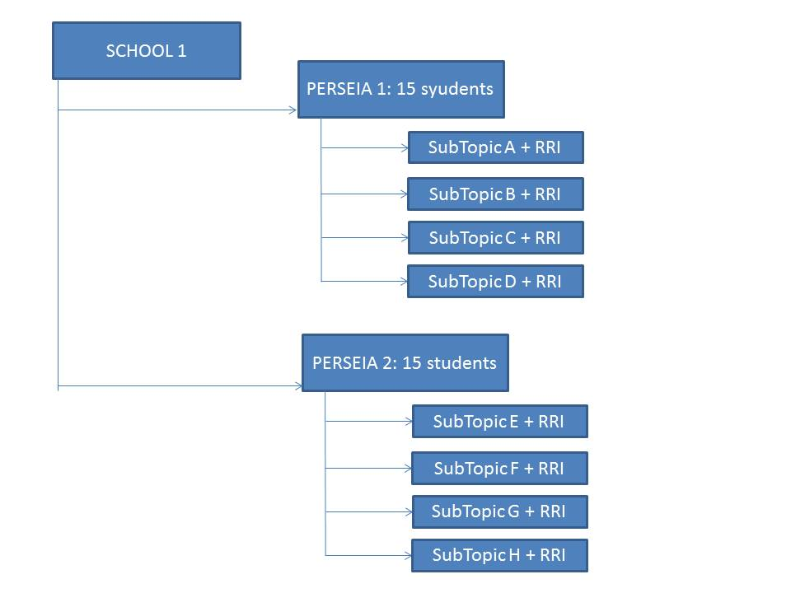

* **RRi inclusion in PERSEIAs**

1. Task 2.1-PERSEIAs can be delivered into 10 to 16 schools until December. In SMS case, they have to delivery before starting Participatory Workshops corresponding to Task 2.2
2. Task 2.1-PERSEIAs will be delivered in a Science Festival in case of SMS
3. Wendy Sadler from SMS does not be SMS-Responsible Person in UK CS any more. Will be substituted by Reachel in one month or so
4. Meriem Fresson from SMS does not be TRACES-Responsible Person in France CS any more. Will be substituted by Céline and Paul.
5. SMS and TRACES will send FG-Data completed before end of May 2016
6. All Task 2.1-PERSEIAs will be composed by short sketches
7. Each sketch will focus, at least, one RRI topic
8. All PERSEIA will have interaction with the public
9. During the session, ideas and approximations were shared between the group.

**Commitments related to WP3:**

**Trainings for Early Career Researchers**

We will aim to keep the timings that we have at the moment, but we may need to be flexible to adapt to ECR availability in order to have participation.

**France**

**When:** Autumn (October/November)

**How:** 1 week concentrated training including reflexivity and other skills (communication, working with schools and teenagers, participatory approaches, evaluation, etc) in Bidart.

Communication skills part of the training to be delivered in French. Link with Traces in order to do so in France. Link with TBVT to delivery it in Spain.

Sam (UoB), Ellie (UoB), Maria (UAB) and Isa (UOC) to attend the part of reflexivity in order to work on redelivery in Bristol and Barcelona

**Bristol**

**When:** End of the year or from January. Probably to happen at the same time as researchers start visiting schools.

**How:** It will be organised as an afternoon course over different weeks.

Sam and Ellie will lead on the reflexivity part with assistance from Atelier (maybe online assistance). Other professionals of engagement will deliver the bits on other sills.

**Barcelona**

**When:** End of the year, after the France one.

**How:** Training organised in different parts.

Isa and Maria to lead on the reflexivity side with support from Atelier. Oriol and Helena for the communication skills. Identify others to do the bit on working with schools (could be CDEC? Open to suggestions).

**Other issues:**

Motivation to get involved and recognition – in each country motivations to get involved in the trainings are different, explore how to sell the training and the participation in the project more generally. Explore recognition by for example UNESCO or other local institutions.

**Trainings for teachers**

The training for the teachers will be targeted at the teachers involved and therefor will be bespoke to the different schools depending on the kind of teachers involved and their needs. The toolkit will be based on different case studies rather than something very general.

Previous to the delivery and design there will need to be meetings with the teachers to get the teachers point of view and to discuss challenges, benefits, as well as training they thing they may need if in the future they were to run such a project on their own. Some skills we anticipate they may need could be how to work with researchers, performance skills, cutting edge research, participation, reflexivity etc.

UoB to meet with the teachers in Bristol between the end of April and May. After these meetings a set of questions and issues to tackle will be sent to Traces and TBVT so that they can gather information about their particular schools.

**Commitments related to WP4:**

* **RRi operationalization and process requirements within PERFORM (June 2016):**  it is agreed that, in June 2016, WP4 will propose to the consortium a set of RRi process requirements to be followed, together with a set of questions to effectively monitor such inclusion along the different stages of the project.

Feedback to these requirements will be asked to PERFORM partners and eventually, a space for discussion will be open online at the beginning of September 2016 to agree a set of minimum common quality RRi process requirements, ensuring that all partners follow the RRi strategy within the project in a rigorous and responsible way.

* **Advancement of the delivery of the assessment strategy and proposed methods to case study coordinators (Nov 2016):** it is agreed that WP4 adapts its calendar to deliver the assessment methods in November 2016 to case study coordinators and ensure that they are available when starting the PERSEIAs development - i.e., general assessment strategy, surveys pre- and post- implementation and any required interview. The calendar of delivery will take into account the time needed for feedback from the CSCs and the pilot testing required.

WP4 raises their concern about the timing and the following is agreed:

* TBVT will share the general structure and goals of the five workshops (Task 2.2) at the beginning of October (we suggest the first week), so it can be taken into account in the evaluation design as it was initially foreseen
* The workshops in UK will not start before the end of November 2016. SMS will communicate the foreseen starting data as soon as they know it, so as to accurately adapt both the calendars of WP2 and WP4.

**Commitments related to WP5:**

* **UNESCO will introduce PERFORM in the programme of ESOF2016 through SMS (July 2016):** EuroScience Open Forum (ESOF) is a European forum held every two years, dedicated to scientific research, innovation and outreach. It was designed by EuroScience (www.euroscience.org) as a unique opportunity in Europe to present and discuss the frontiers of scientific and technological advancement, the relationships between science and society, and the policies supporting research. The core of ESOF is the Scientific Programme, but the ESOF2016 programme also features a Science to Business Programme, a Science in the City Programme and a Career Programme specifically dedicated to young researchers as well as researchers to be.UNESCO agreed with the ESOF organizers and SMS to introduce PERFORM in the programme of ESOF2016 through SMS.
* **Organization of a two-day meeting to present and promote PERFORM to the UNESCO’s Permanent Delegations and the general public at the occasion of the World Science Day for Peace and Development (Nov 2016):** Established by UNESCO in 2001, the World Science Day for Peace and Development (WSDPD) is celebrated worldwide on 10 November each year. The day offers an opportunity to mobilize various partners to highlight the important role of science in society and to engage the wider public in debates on emerging scientific issues and the relevance of science in their daily lives.

UNESCO organizes a two-day meeting to present and promote PERFORM to the UNESCO’s Permanent Delegations and the general public at the occasion of the World Science Day. A tentative programme of work:

WEDNESDAY 9TH NOVEMBER

• Consortium meeting, including the 3rd Steering Committee meeting (9 am to 1 pm)

• Presentation of PERFORM to UNESCO delegation with Performance (3 pm to 5 pm)

• Dinner with Performers

THURSDAY 10TH NOVEMBER

• World Science Day 2016

• Presentation of PERFORM to UNESCO delegation with Performance (3 pm to 5 pm)

• Dinner with Performers