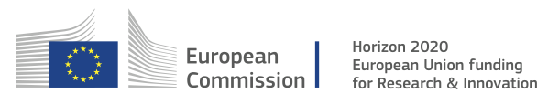

PERFORM CALENDAR FOR 2017 AND 2018

