CURRICULUM VITAE

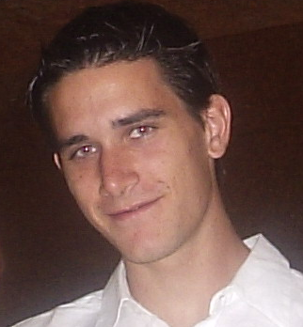
Personal data:
♦Name: Javier
♦Surname: Santaolalla Camino
♦Age: 25 (08.31.1990)
♦Marial status: bachelor.
♦Address: Av/José Ramírez Bethencourt Nº30 5ºG

Academic Data:

- BUP (bachillerato) at San Antonio Maria Claret School with a mark of: “Sobresaliente” (8,98,over 9).
- COU at San Antonio María Claret School with a mark of “Matrícula de Honor” (10 over 10).
- Selectividad exam to access university through the ULPGC with a mark of 8,01 over 10.
- First cycle of Superior Telecommunication Engineering, having already passed my 4th and 5th year and therefore only having my end- year- project to finish the degree.

Work experience:
♦ 2000 - 2004: private tennis classes, to children and adults.
♦2000 - 2002,2004 and 2005 : English, mathematics, physics private classes to students from EGB, BUP and COU.
♦ 2004: creation of the website www.delicioso.co.uk.
♦ 2004 - 2005: design of a software tool for the statistic control of university data with html and php, as a scholarship holder at the Administrative Building of Las Palmas University between May 2004 and February 2005, with 12 hours per week.

Complementary Education
♦Studying Physics at UNED, at the moment at 3rd course with only five courses to finish the first cycle.
♦Studying French at “Escuela Oficial de Idiomas”. At the moment at 3rd level, having passed the first and second year successfully with a mark of 7 over 10.
♦Advanced French course of 50 hours during 2 weeks at L’École Nationale Supérieure des Télécommunications in Bretagne, France, summer 2003.
♦Intensive French course at Institut Linguistique Adenet, in Montpellier during three weeks with a total of 45 hours, with a scholarship of the Spanish Government, summer 2004.
♦ Firewalls and Security in Internet course, organised by the University of Las Palmas de Gran Canaria, with a total duration of 80 hours.
♦Advanced non-official piano studies.
♦Participation on the “Seventh International Conference on the History of General Relativity” in La Orotava, Tenerife, March 2005. Organised by Fundación Canaria Orotava, Max-Planck Institut fur Wissenschaftgeschichte and Instituto de Astrofísica de Canarias.
♦”Introduction to Standard of of image and video compression” course for 25 hours, April 2005.
♦Studying “Introduction to Quantum Computation” as a free choice course at Computer Engineering’s faculty.

Other information:
- “Trofeo Rector” tennis champion in 2003 (University of Las Palmas de Gran Canaria Tennis Tournament) and paddle second place the same year.
- Driving licence and own car.
- Beneficiary of one of the 40 scholarships that grants the “Asociación Mutualista de Ingenieros Civiles” (AMIC) awarding the best academic files of engineering students in Spain, from 2001 to 2005
- Scholarship from the Spanish Government during the complete degree.

