MINUTES of WP2 SESSIONS DURING KNOWLEDGE SHARING WORKSHOP

Bristol. 4-8 April 2016

**Monday 4, afternoon.**

Revision of FG and FG-Results from Spain.

Assistants:

WP2: Helena González, Oriol Marimon, Leanne Gunn, David Price, Paul Boniface.

WP3: Mireia Bes, Sam Pollock, Ellie Hart, Kat Wall, Fiona Hyland, Kate Miller, Jon James, Livio Riboli-Sasco, Claire Ribrault

WP4: Isabel Ruiz, Maria Heras, Erick Jensen

WP6: Casimiro Vinzini

Conclusions:

1. FG improvement suggestions have been applied to FGs. See Reformulated-FG.
2. FG sessions have to be recorded
3. FG have to be renamed to Participatory Workshops
4. Diversity group from “Consell de Cent” have to be tacked out from analysis.
5. Reanalyse subcategories in FG1
6. Analyse Low/Medium independently
7. Analyse Spain/France/UK independently
8. Include students opinions that allows us to extract conclusions

**Wednesday Morning**

Task 2.2 organization

Assistants:

WP2: Helena González, Oriol Marimon, Leanne Gunn, David Price, Paul Boniface.

WP3: Mireia Bes, Sam Pollock, Ellie Hart, Kat Wall, Fiona Hyland, Kate Miller, Jon James, Livio Riboli-Sasco, Claire Ribrault

WP4: Isabel Ruiz, Maria Heras

WP6: Casimiro Vinzini

Conclusions:

Participatory workshops of Task 2.2 will be implemented following next scheme:

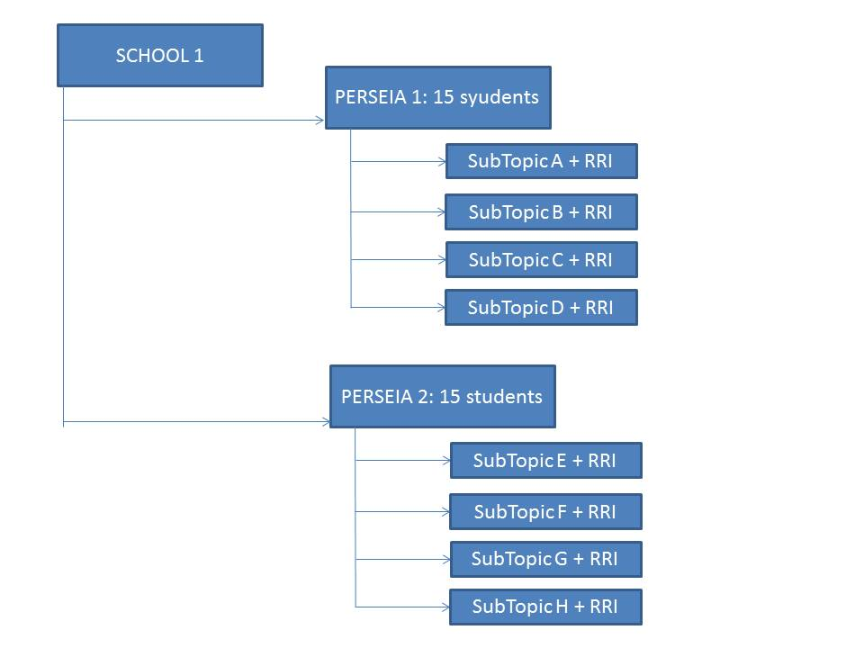

**Friday 8, afternoon.**

How to include RRI into PERSEIAs

Assistants:

WP2: Helena González, Oriol Marimon, Leanne Gunn, David Price, Paul Boniface, Bérénice Collet, Anissah Benchelah

Conclusions:

1. Task 2.1-PERSEIAs can be delivered into 10 to 16 schools until December. In SMS case, they have to delivery before starting Participatory Workshops corresponding to Task 2.2
2. Task 2.1-PERSEIAs will be delivered in a Science Festival in case of SMS
3. Wendy Sadler from SMS does not be SMS-Responsible Person in UK CS any more. Will be substituted by Reachel in one month or so
4. Meriem Fergusson from SMS does not be TRACES-Responsible Person in France CS any more. Will be substituted by Céline and Paul.
5. SMS and TRACES will send FG-Data completed before end of May 2016
6. All Task 2.1-PERSEIAs will be composed by short sketches
7. Each sketch will focus, at least, one RRI topic
8. All PERSEIA will have interaction with the public
9. During the session, ideas and approximations were shared between the group.